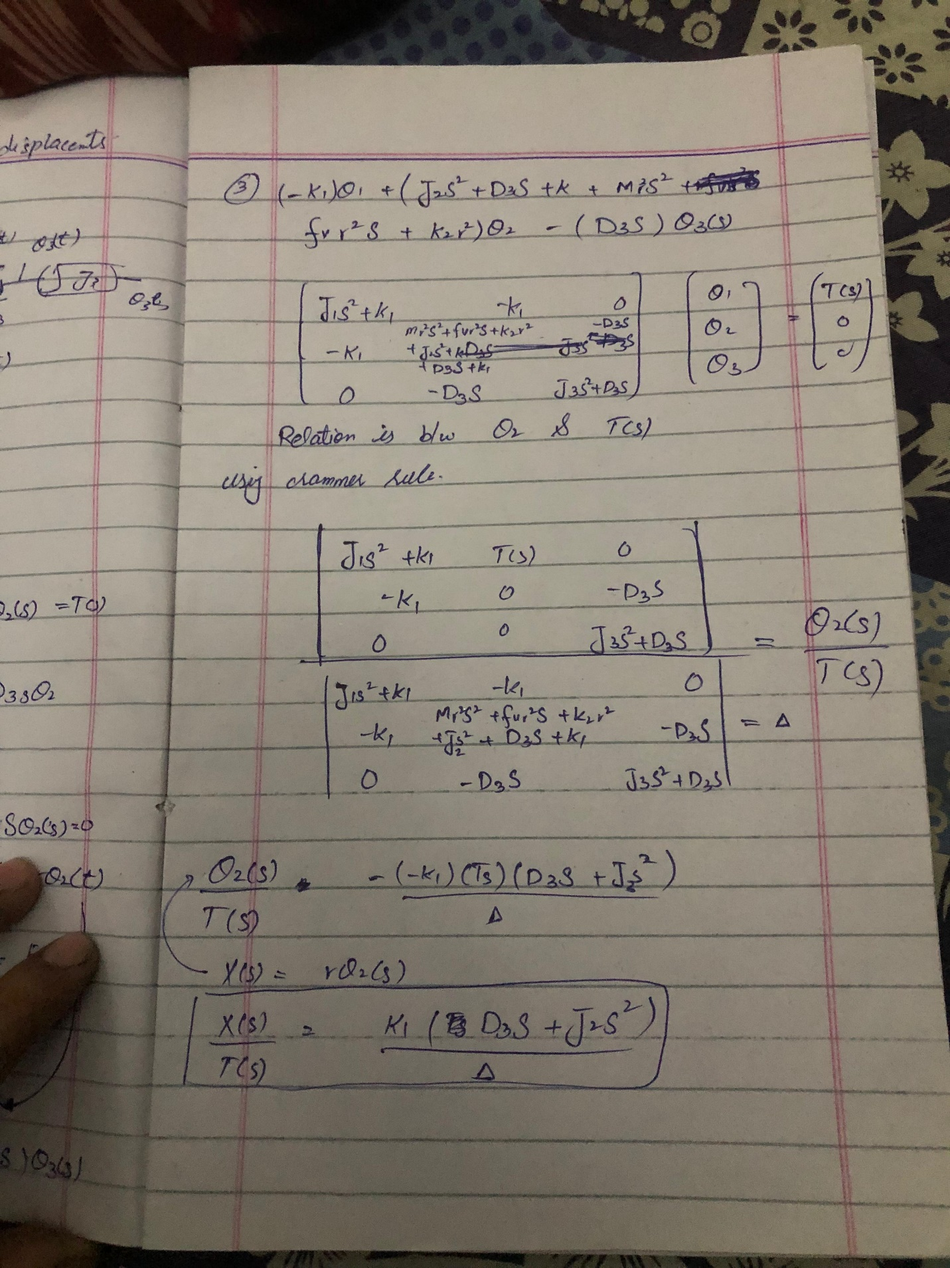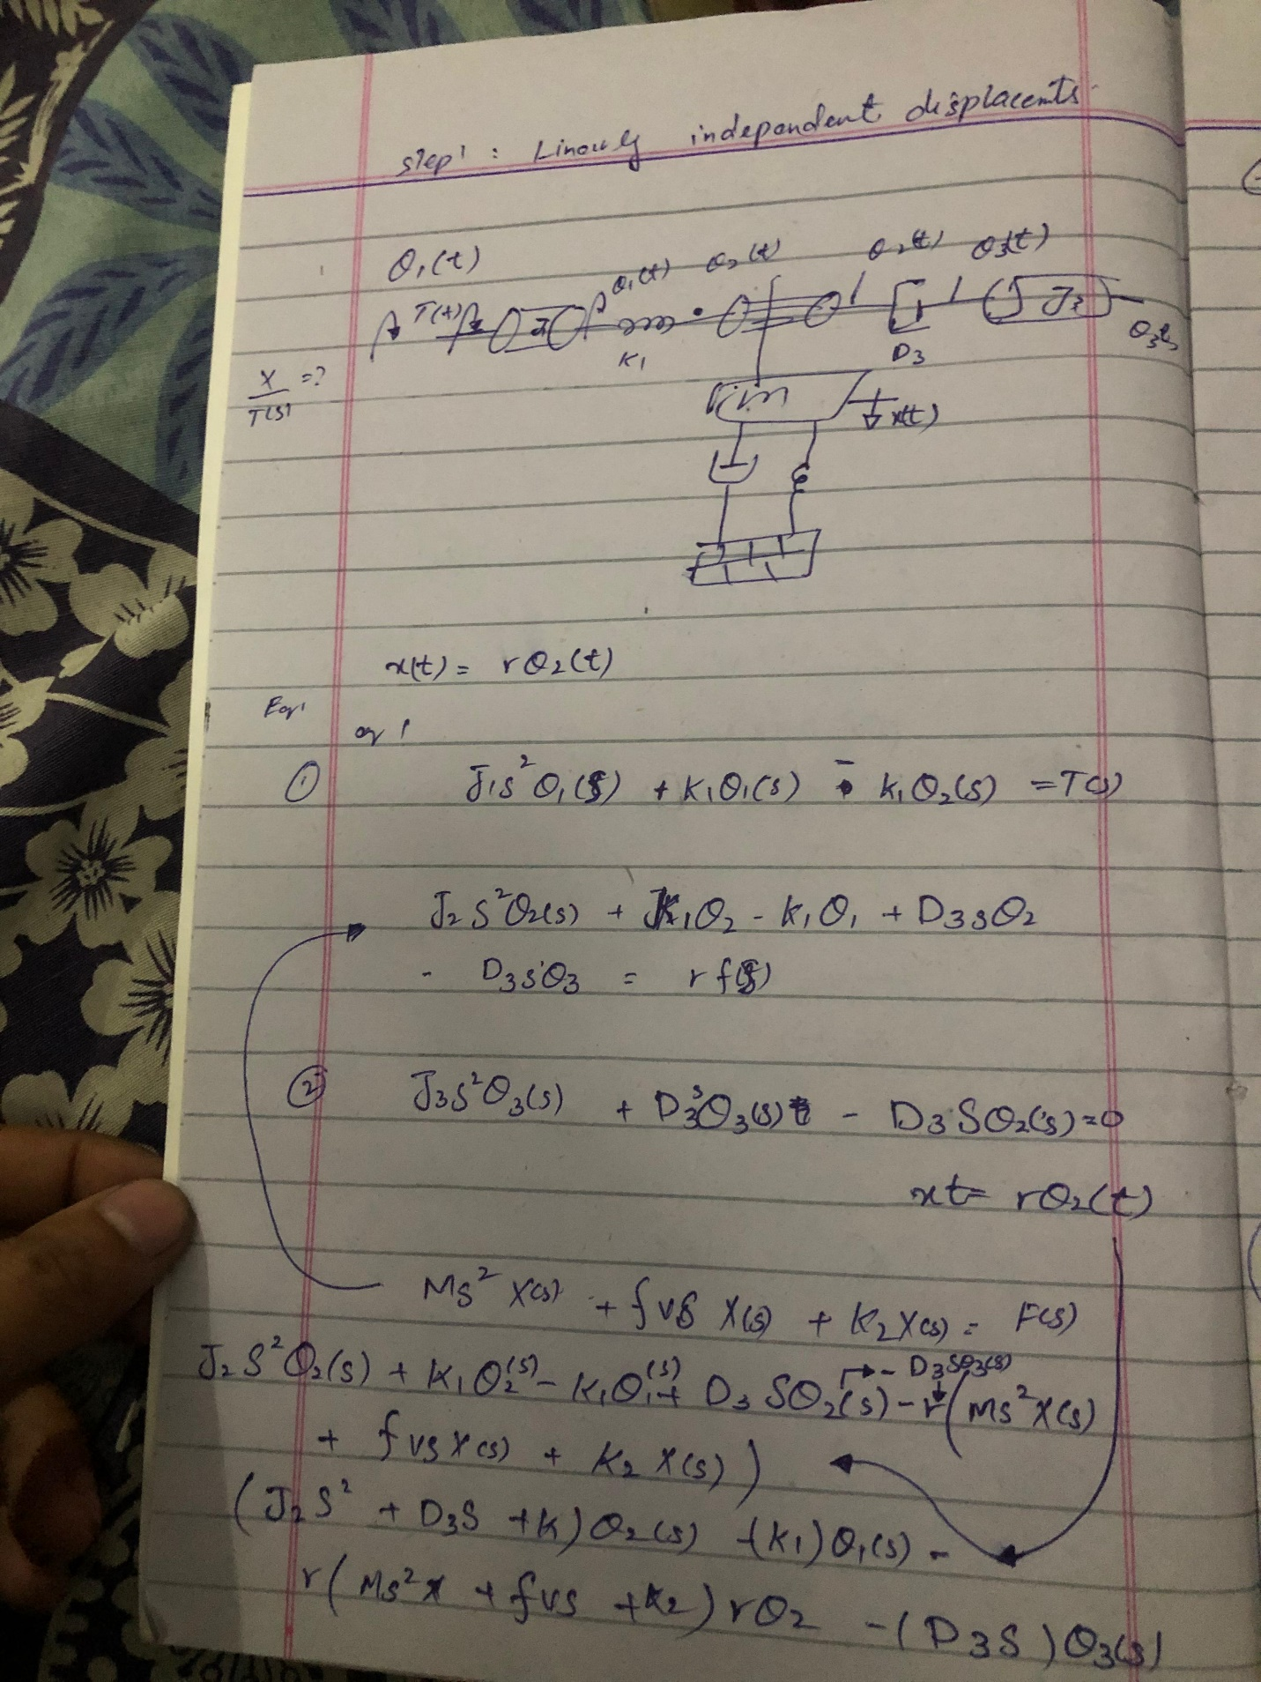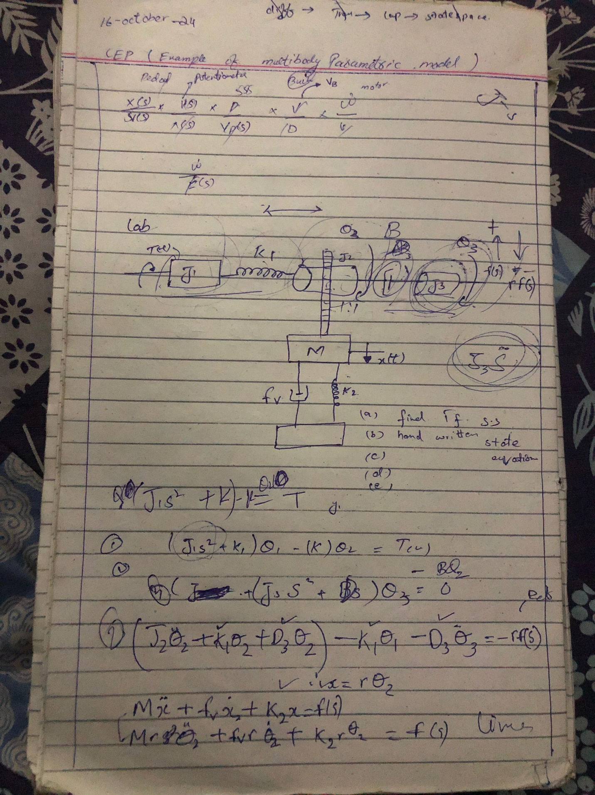

clc ;

% Transfer function (Theta_gear(s) / T(s))

num = [1]; % Numerator

den = [J1 0 k1]; % Denominator

% Create transfer function

sys_tf = tf(num, den)

% State-space matrices

A = [0 1 0 0 0 0;

-k1/J1 0 k1/J1 0 0 0;

0 0 0 1 0 0;

k1/(J2+m*r^2) 0 -(k1+k2*r^2)/(J2+m*r^2) -(fv*r^2+d3)/(J2+m*r^2) 0 d3/(J2+m*r^2);

0 0 0 0 0 1;

0 0 0 d3/J3 0 -d3/J3];

B = [0; 1/J1; 0; 0; 0; 0];

C = [1 0 0 0 0 0];

D = 0;

% Create the state-space system

sys_ss = ss(A, B, C, D);

%% Part A Variant Torque

clc;clear;

TR = [0 50];

X0 = [0;0;0;0;0;0];

k1=50;k2=50;fv=50;d3=30.5;T=40;m=15;J1=20;J2=10;J3=16;r=7.5;

for T=10:5:30

[t,y]= ode45(@(t,y)randFun2(t,y,T,J1,J2,J3,m,r,fv,k1,k2,d3),TR,X0);

thGear=y(:,3);

omGear=y(:,4);

x=r*thGear;

v=r*omGear;

% Compute acceleration

a1 = gradient(v, t);

a2 = gradient(omGear, t);

subplot(2,3,4)

plot(t,thGear)

hold on

xlabel('time')

ylabel('theta-Gear')

subplot(2,3,5)

plot(t,omGear)

hold on

xlabel('time')

ylabel('Angular velocity-Gear')

subplot(2,3,1)

plot(t,x)

hold on

xlabel('time')

ylabel('displacement')

subplot(2,3,2)

plot(t,v)

hold on

xlabel('time')

ylabel('velocity')

subplot(2,3,3)

plot(t, a1)

hold on

xlabel('time')

ylabel('Acceleration-1')

subplot(2,3,6)

plot(t, a2)

hold on

xlabel('time')

ylabel('Angular acceleration-Gear')

end

for i=1:6

subplot(2,3,i);legend('10N Torque', '15N Torque', '20N Torque','25N Torque', '30N Torque')

end

%% Part B Variant Radius

clc;

clear;

TR = [0 50];

X0 = [0;0;0;0;0;0];

k1=50;k2=50;fv=50;d3=30.5;T=40;m=15;J1=20;J2=10;J3=16;r=7.5;

for r=1:1:8

[t,y]=ode45(@(t,y)randFun2(t,y,T,J1,J2,J3,m,r,fv,k1,k2,d3),TR,X0);

thGear=y(:,3);

omGear=y(:,4);

x=r*thGear;

v=r*omGear;

% Compute acceleration

a1 = gradient(v, t);

a2 = gradient(omGear, t);

subplot(2,3,4)

plot(t,thGear)

hold on

xlabel('time')

ylabel('theta-Gear')

subplot(2,3,5)

plot(t,omGear)

hold on

xlabel('time')

ylabel('Angular velocity-Gear')

subplot(2,3,1)

plot(t,x)

hold on

xlabel('time')

ylabel('displacement')

subplot(2,3,2)

plot(t,v)

hold on

xlabel('time')

ylabel('velocity')

subplot(2,3,3)

plot(t, a1)

hold on

xlabel('time')

ylabel('Acceleration-1')

subplot(2,3,6)

plot(t, a2)

hold on

xlabel('time')

ylabel('Angular acceleration-Gear')

end

for i=1:6

subplot(2,3,i);legend('1m radius', '2m radius', '3m radius','4m radius', '5m radius', '6m radius', '7m radius', '8mradius')

end

function dy= randFun2(t,y,T,J1,J2,J3,m,r,fv,k1,k2,d3)

dy(1)=y(2);

dy(3)=y(4);

dy(5)=y(6);

dy(2)=1/J1*(T - k1*y(1) + k1*y(3));

dy(4)=1/(J2+m*r*r)*(k1*y(1) - (d3+fv*r^2)*y(4) -(k1+k2*r^2)*y(3) + d3*y(6));

dy(6)=1/J3*(d3*(y(4)-y(6)));

dy=dy';

end